Objective: Design a workflow where phones of price less than or equal to 15000 needs to be copied from the soure table to the target table.

Selected the source and selected the connection mysql and selected the Object Phone, which is a source table
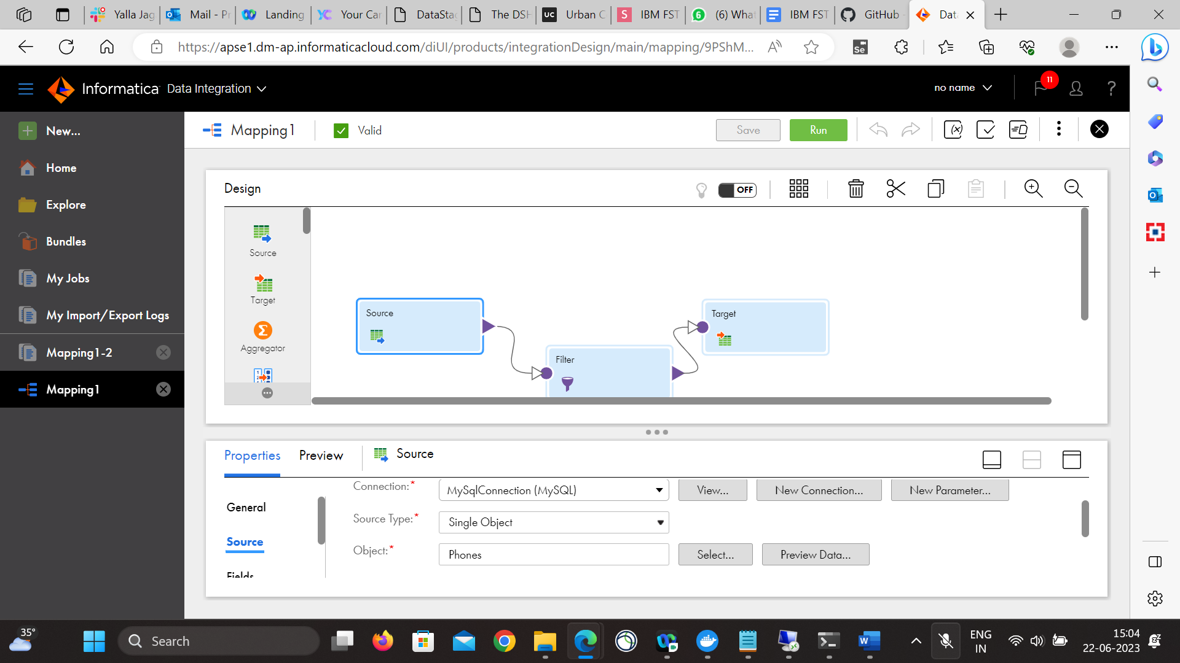

Under Fields, we will see all the fields got populated for the Phones table.
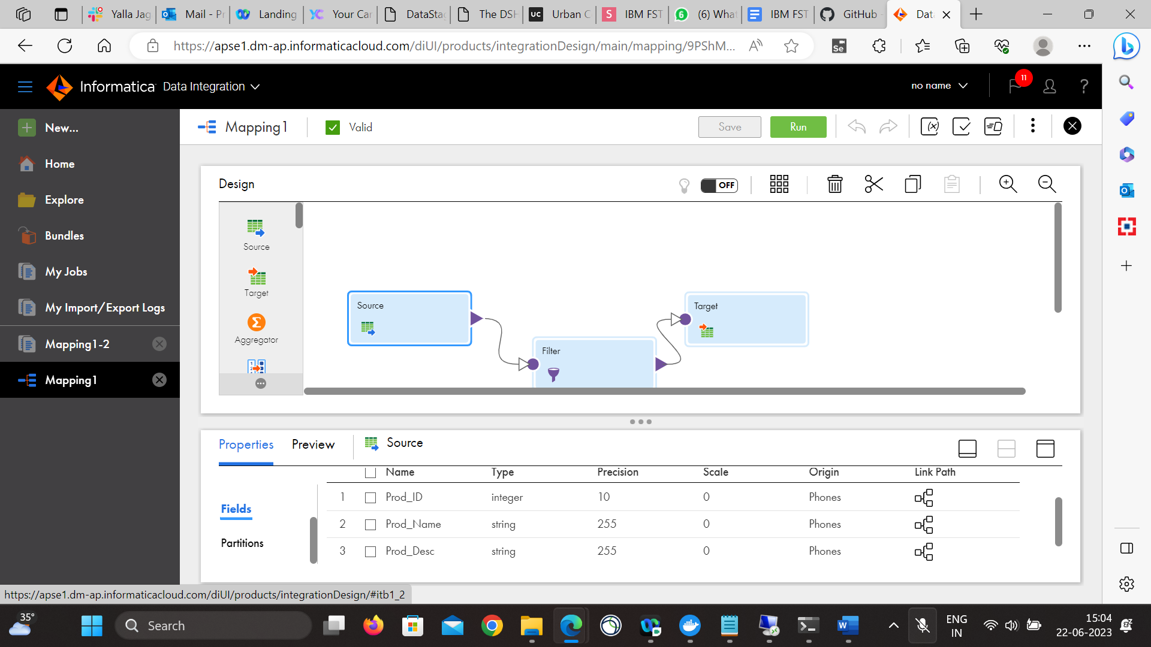

Selected the Filter now

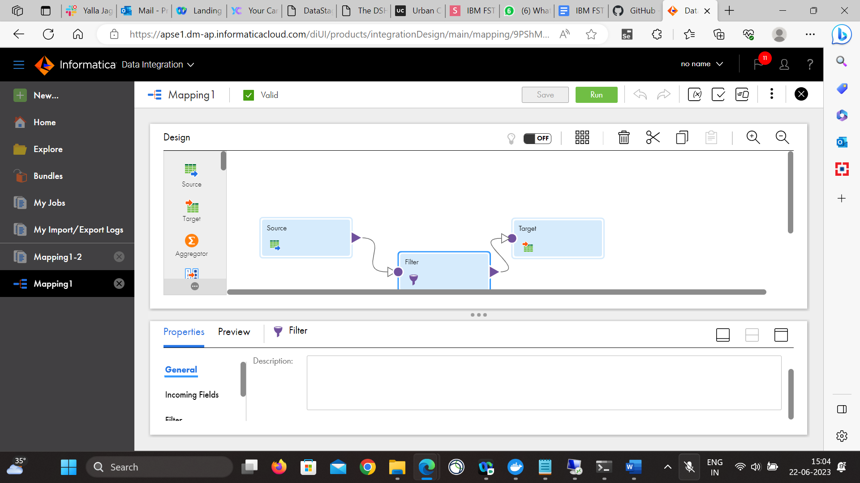

Under Filters, all incoming fields are automatically included
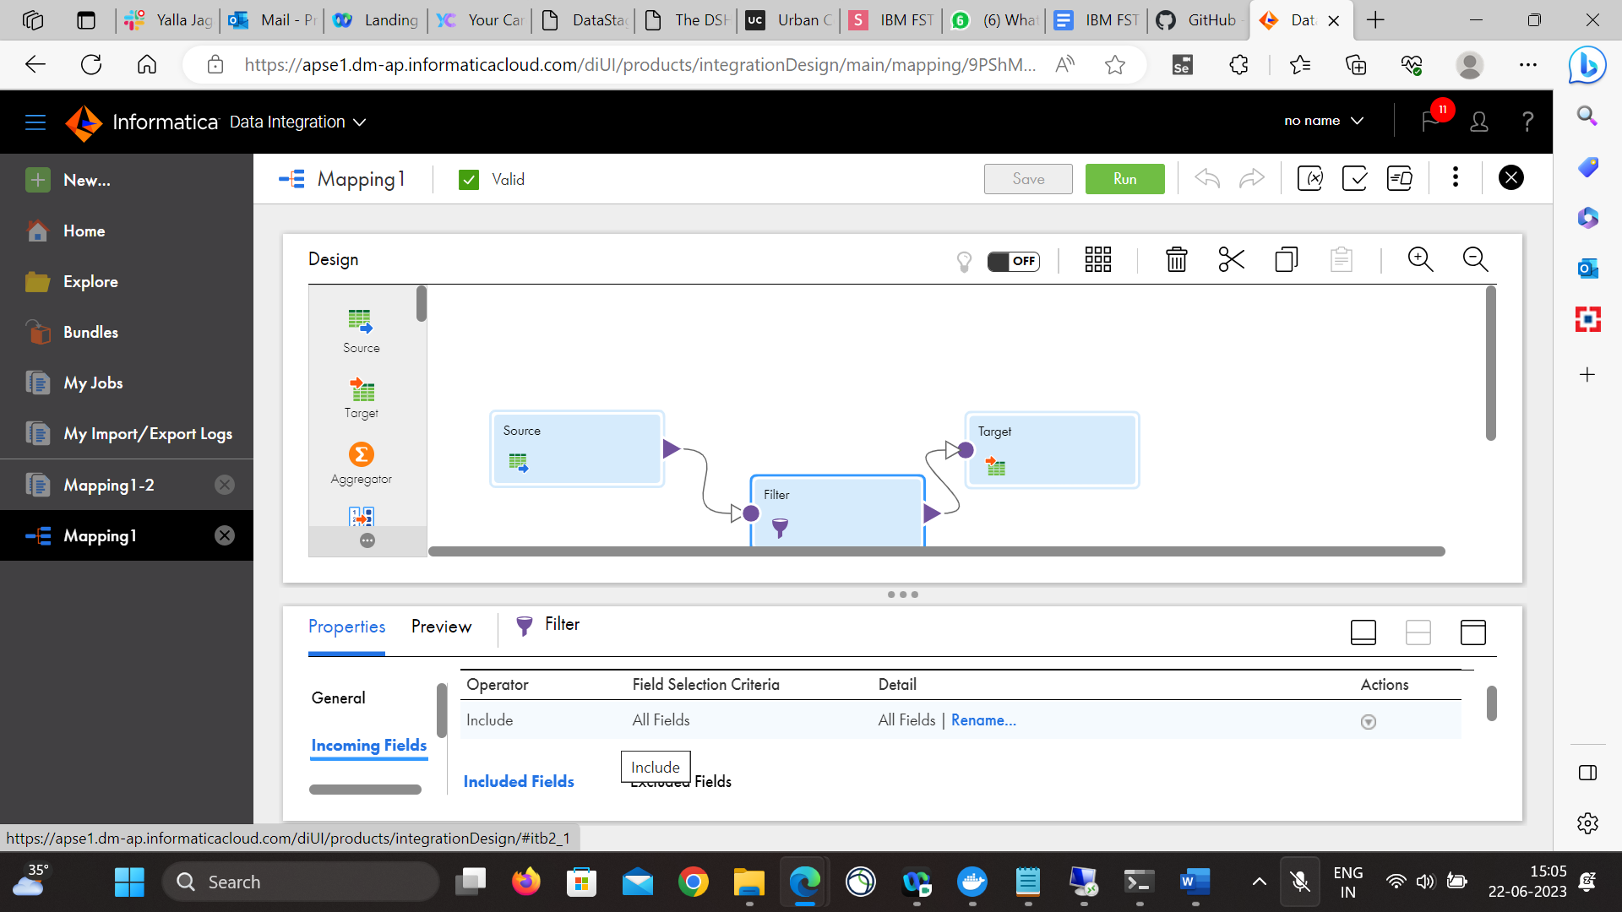

Under Filter option, we have given the condition like Prod_Price<=15000.
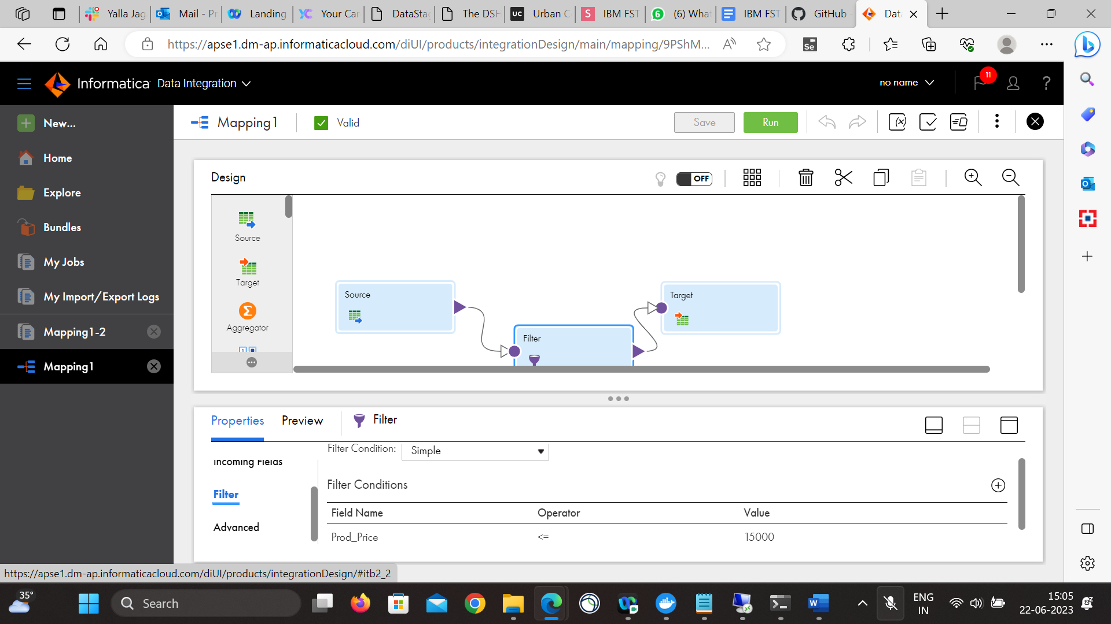

Selected the Target

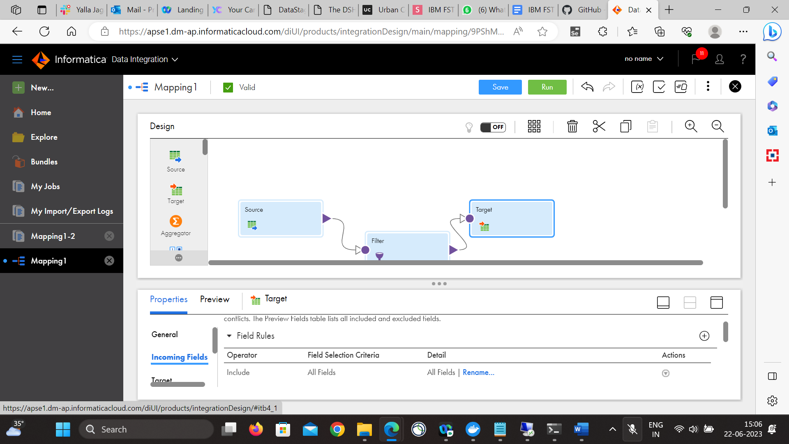

Under Target, we have selected the connection mysql and selected the object as ‘Budget_Phones_Praveen’, which is a new table created for output purpose.

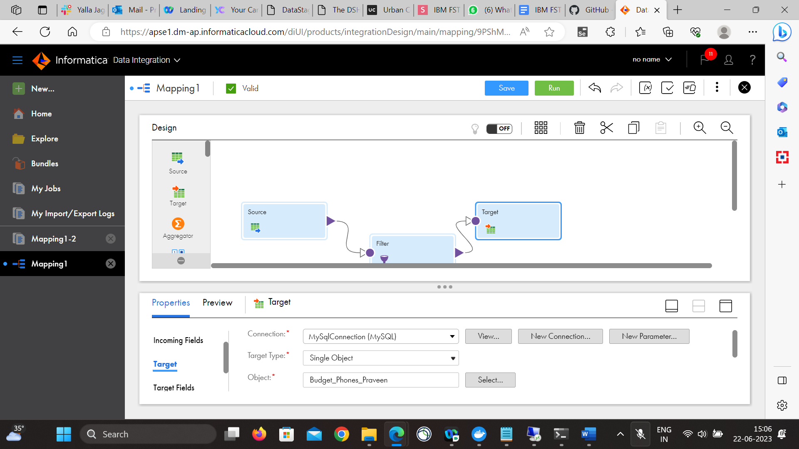

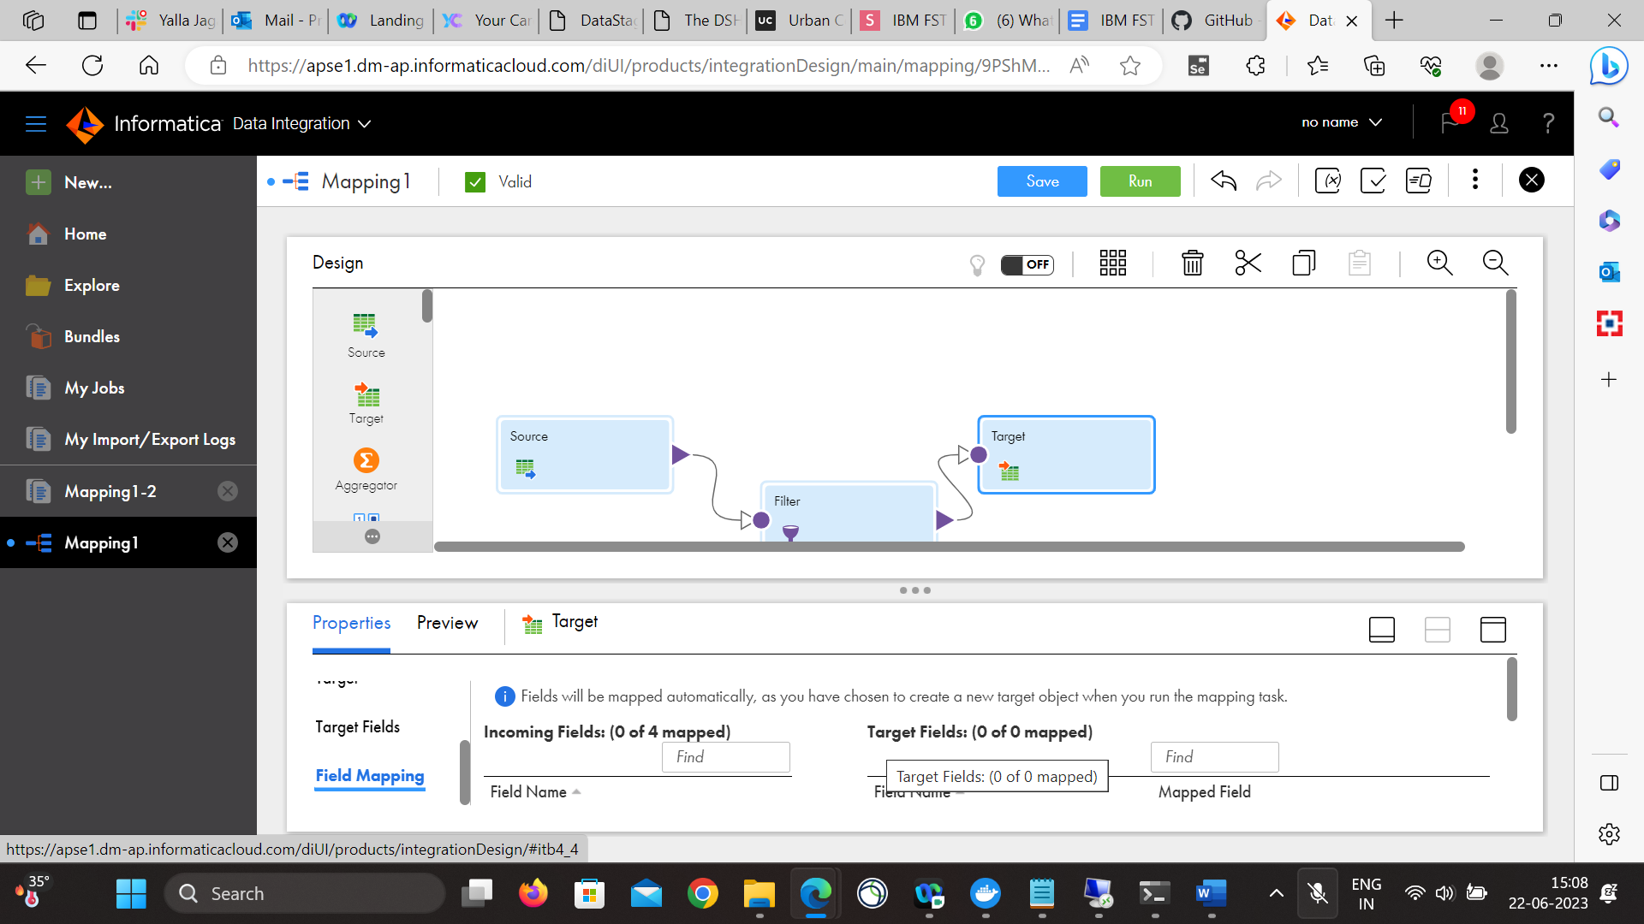

Finally the job got executed successfully as shown below with instance name of Mapping1-2, where 9 jobs got processed successfully.
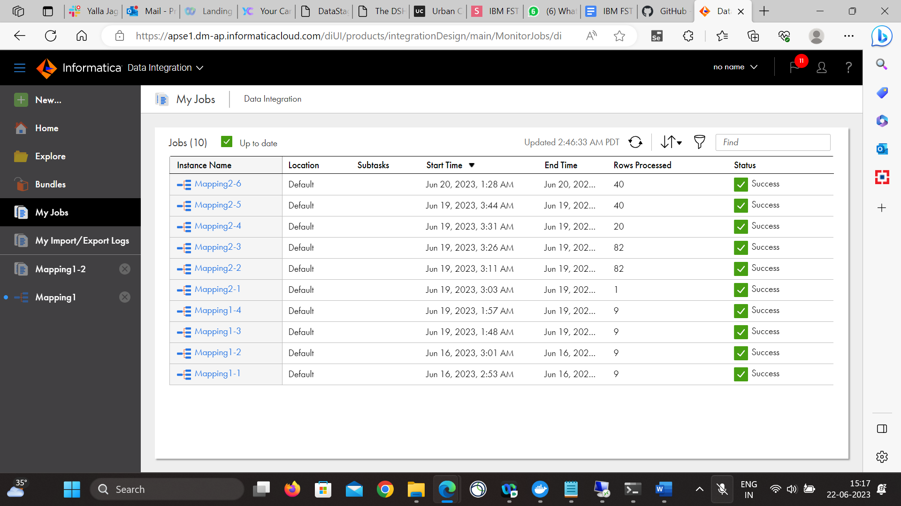

The output log is downloaded and attached to the activity.

